J. K. ROWLING, *Harry Potter et le Prisonnier d’Azkaban*, 6, p.88-90.

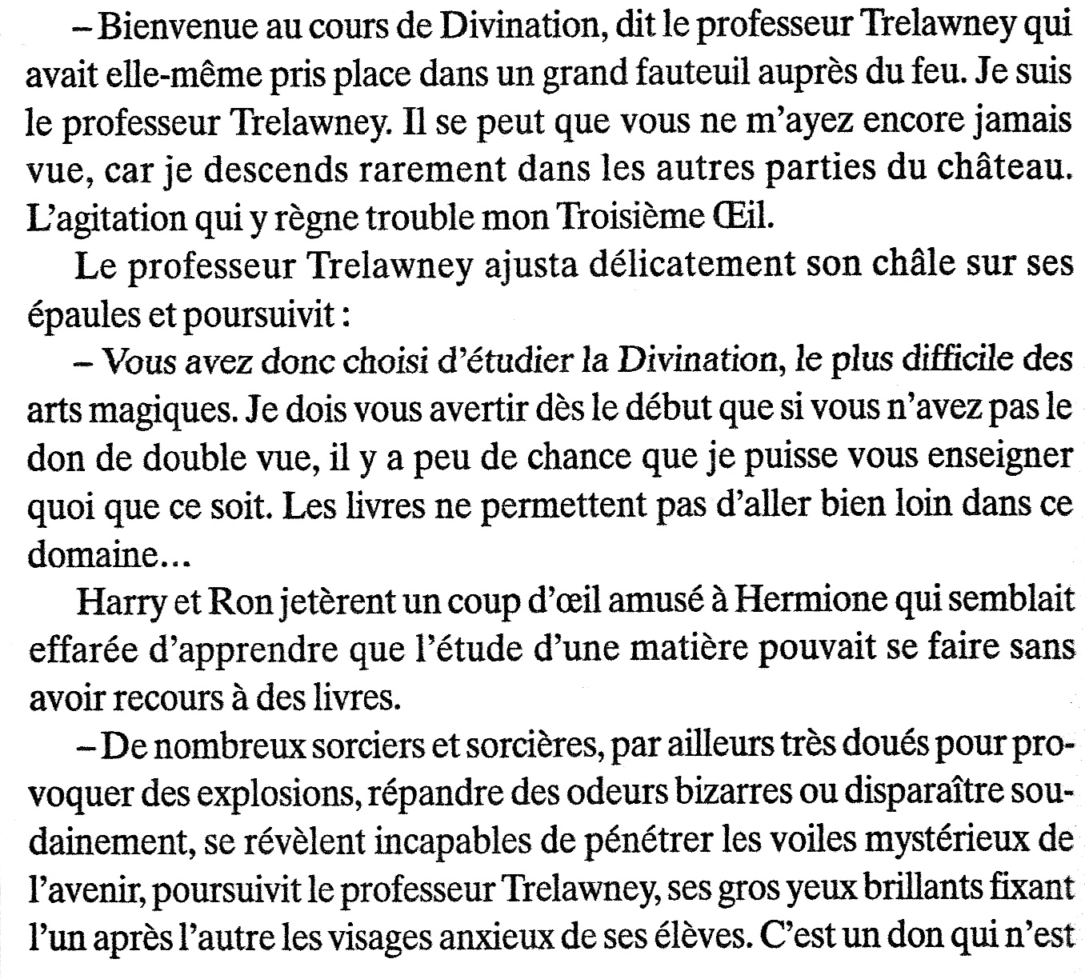

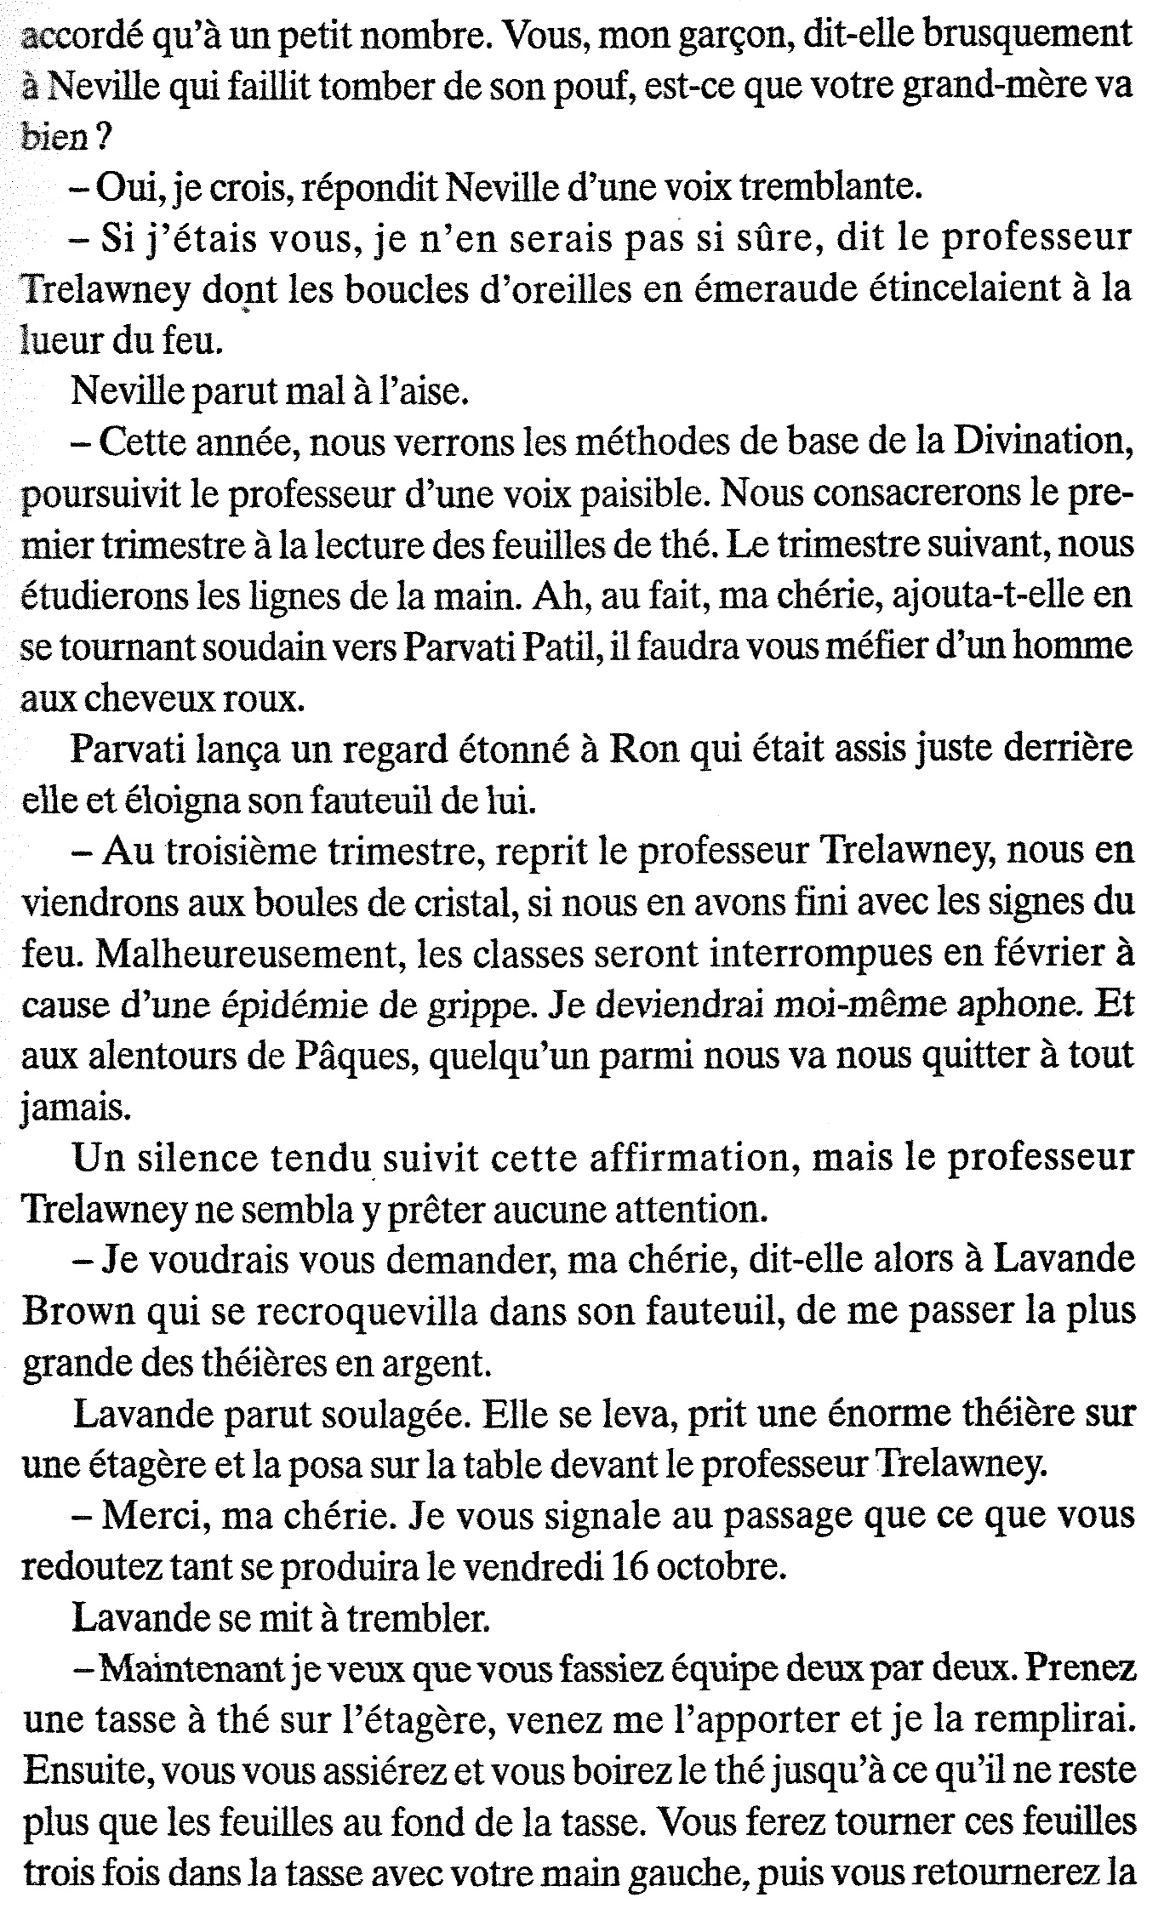

[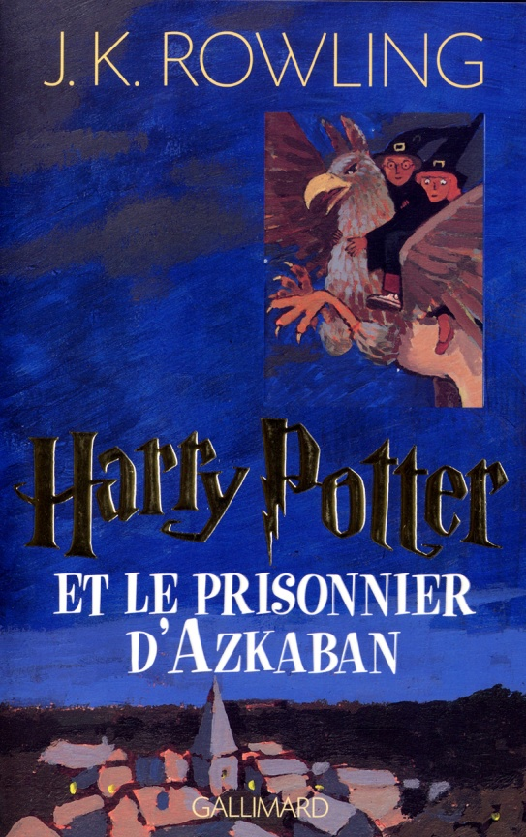](https://www.google.com/url?sa=i&url=https://www.amazon.fr/Harry-Potter-Prisonnier-dAzkaban/dp/2070541304&psig=AOvVaw3oY1CzXQGXDIa-bArB1kcq&ust=1583145918926000&source=images&cd=vfe&ved=0CAIQjRxqFwoTCKivoKOM-ecCFQAAAAAdAAAAABAE)